**JAVAIRIA REHMAN**

**19P-0020**

**BS(CS) 19-5A**

**“computer network lab ”**

**Lab 10 home work**

**STEPS OF MAKING TOPOLOGY**

1. **MAKE SENERIO**

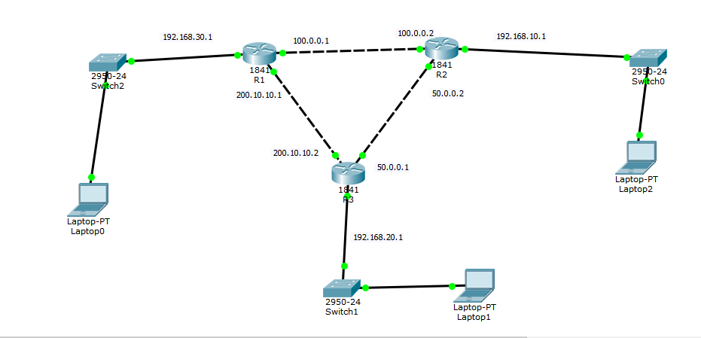

1. **CONFIGURATION OF ROUTERS**

* **ROUTER 1**

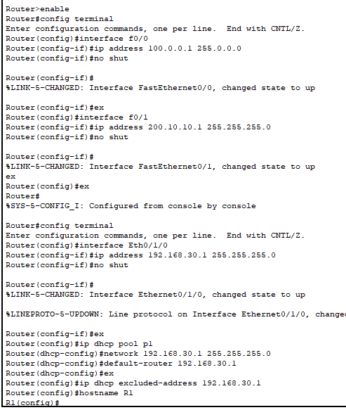

* **ROUTER 2**

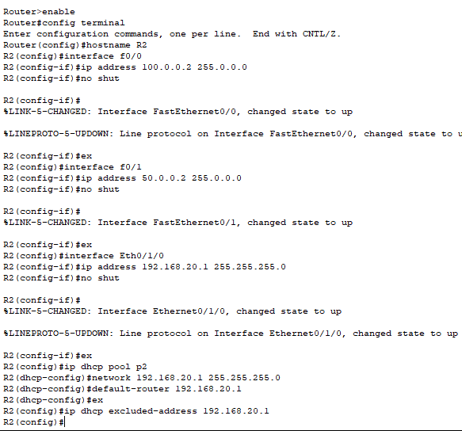

* **ROUTER 3**

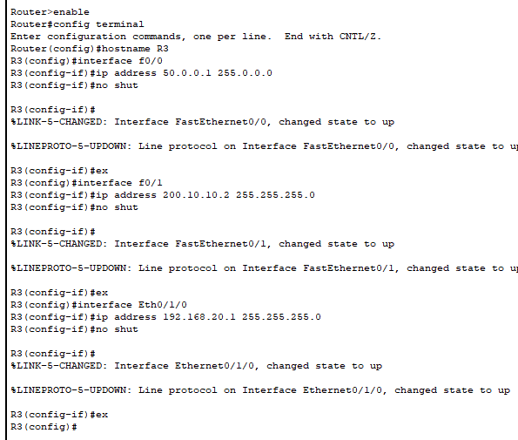

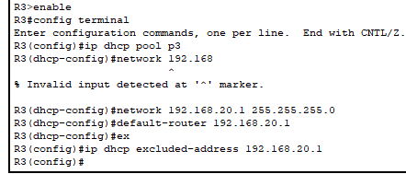

1. **ASSIGNING ROUTES TO ROUTER**

* **ROUTER 1**

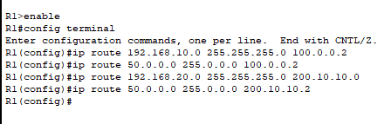

* **ROUTER 2**

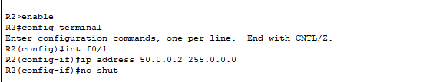

* **ROUTER 3**

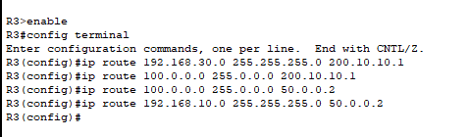

1. **Packets travelling**

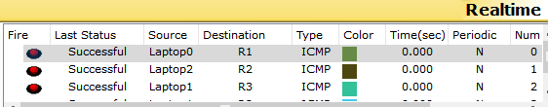

1. **Pc values updated**

* **Pc 1**

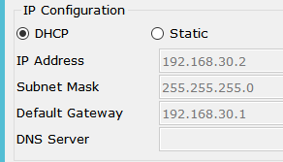

* **Pc 2**

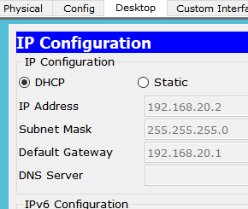

* **Pc 3**

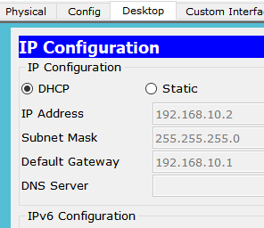

**Question 2 answer**

There are total 6 networks and we make 3 pools for this senerio

Networks are mentioned below

